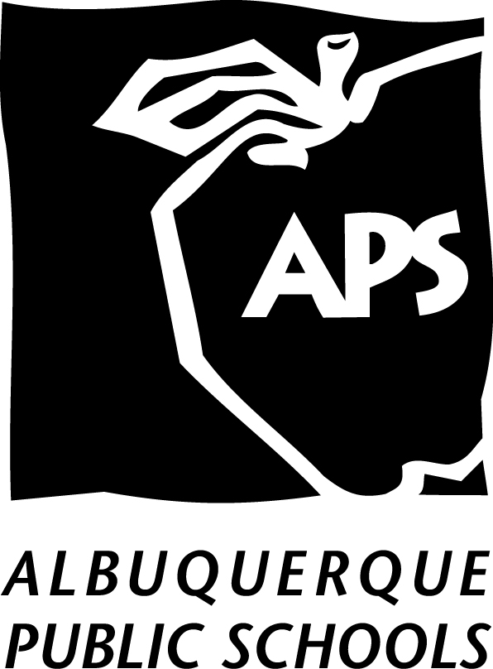
Albuquerque Public Schools
Title I District Family Engagement Policy 2022-2023

The Albuquerque Public Schools Title I Department shall publish a Family Engagement Support Agreement that informs parents/legal guardians within the district of the ways the Department supports Family Engagement at the schools and within the district. The Family Engagement Support Agreement shall be the response to parent/legal guardian requests for a shorter, more understandable document explaining the work of the Title I Department in providing Family Engagement support to participating Title I schools. The following bulleted items explain in detail the items that are contained in the Family Engagement Support Agreement.
- The Title I Department shall notify parents/legal guardians, through the Title I website and information brochures, of their right to be involved in the review and improvement of the Title I program, and of the fact that the Title I Program Plan becomes part of the District Consolidated Application.
- The Title I Department shall provide support and technical assistance to Title I schools in posting to their websites. An alternate format in hard copy are available in the school office.
- The Title I Department, through orientation, ongoing professional development, and ongoing onsite support, shall provide support and technical assistance to Title I schools in planning and implementing effective family engagement activities focused on the improvement of student academic achievement in reading, math, science, and overall school performance.
- The Title I Department shall build the schools’ and parents’/legal guardians’ capacity for strong family engagement by:
  - Providing materials and resources to schools to assist them in helping the families of students that are being served in Title I schools to understand state standardized school assessments, and how to access information on their child’s progress.
  - Providing materials and information at the ongoing Title I Family Liaison Professional Development meetings regarding best practices in how to build relationships and have two-way conversations with parents/guardians, how to develop a welcoming environment, and how to encourage parents/guardians to access school resources and increase participation/engagement at the school.
  - Providing information to schools on how to access services from the APS Translation Services program in order to develop materials, as much as is practical, for parents/guardians in a language they can understand.
  - Providing a Family Engagement Resource Teacher to provide professional development and resources to assist schools and parents/guardians in planning and carrying out effective family engagement activities. Title I School Support Resource Teachers shall monitor parent/legal guardian involvement during their compliance visits bi-annually.
- The Title I Department shall collaborate with other APS departments and community organizations to maximize results for family engagement.
- The Title I Department Family Engagement Program shall hold parent/legal guardian meetings annually with the purpose of reviewing and/or revising the District Family Engagement Policy brochure and the APS Title I District Family Engagement Policy.
  - The Title I Department, in collaboration with the APS Office of Accountability and Reporting (OAR) shall collect and analyze data from parent/legal guardian surveys to determine Best Practices in Family Engagement within the district and to share that information with all Title I schools. The information will be available on the Albuquerque Public Schools website.

For a complete version of the State of New Mexico Complaint Procedure, see NMPED Complaint Procedure

Department Director: Title I Executive Director/Title I Family Engagement Program

References: ESSA
Cross Ref.: Section 1116(a).

Policy Cross Ref: Title I 2020-2021 APS District Family Policy

NSBA/NEPN Classification: KB

Revised: February 2022

Parents are children’s first and most influential teachers.

