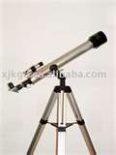  www.corestandards.org  →The Standards-top menu  →English Language Arts Standards-middle of page  →Anchor Standards- left menu  →Drop down College and Career Readiness Anchor Standards for Reading  →Drop down College and Career Readiness Anchor Standards for Writing  →Drop down College and Career Readiness Anchor Standards for Listening and Speaking  →Drop down College and Career Readiness Anchor Standards for Language | Reading
 | Writing
 | Listening and Speaking
 | Language

