Looking Through Different Lenses
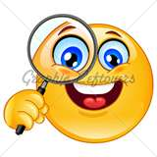  www.corestandards.org  →The Standards-top menu  →English Language Arts Standards-middle of page  →Introduction-left menu  →Drop down How to Read the Standards  →Find Overall Document Organization  →Scroll down Key Features | Overall Document Organization
 | Reading
 | Key Features
 | Writing
 | Key Features
 | Listening and Speaking
 | Key Features
 | Language
 | Key Features

