Discovery Education for APS
- http://aps.discoveryeducation.com/
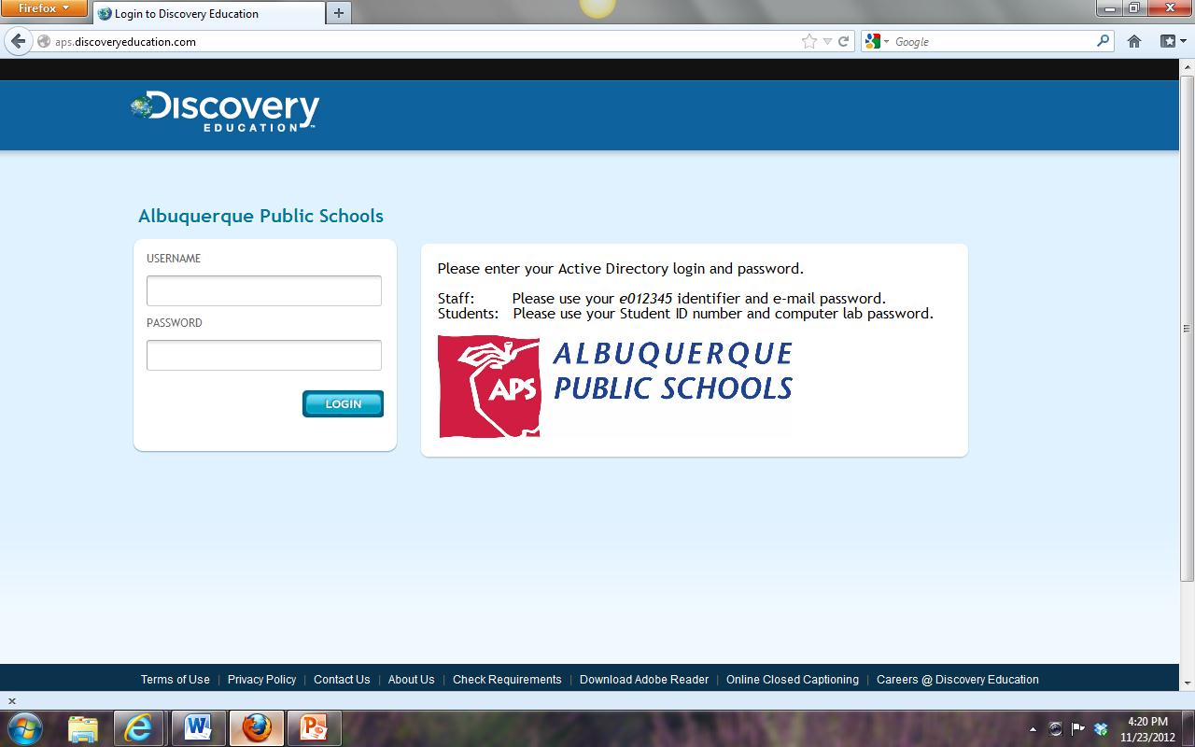

- Social Studies Techbook
The Social Studies Techbook is in the “beta phase” with APS. The techbook is not complete.
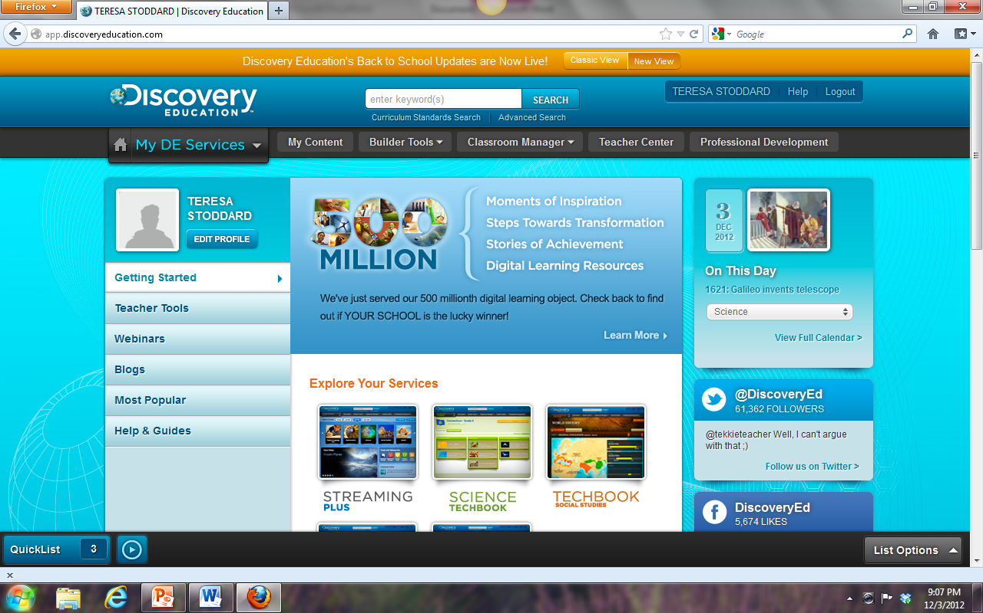

- Course View—World History and United States History
These courses are for middle school.
  - World History covers Human Origins through the Seeds of Modern Europe (1500-1800)
  - United States History covers Three Cultures Meet through Reconstruction.
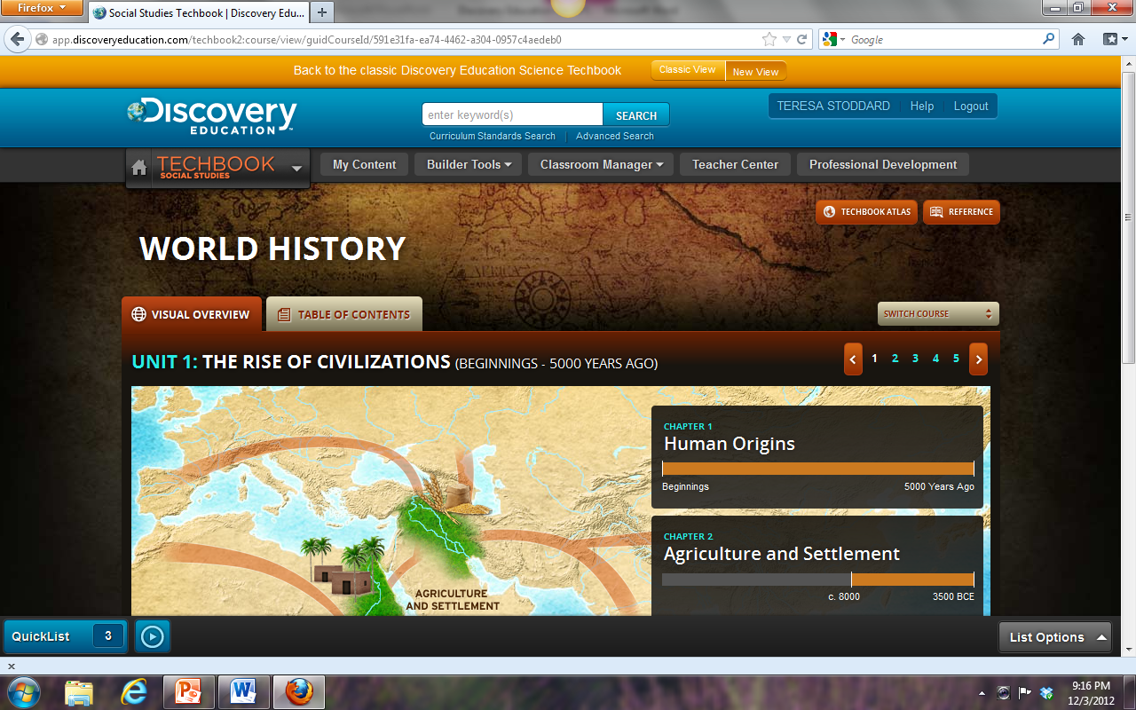
Switch Course lets you move between the two courses.

Click on the chapter to see its sections or concept.

  - This view shows you Unit 1 and its two chapters.
  - Click on a chapter to see the chapter broken down into sections.
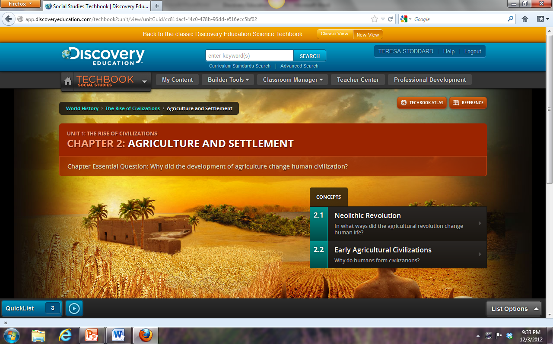
Each chapter has an essential question.

Chapter 2 is broken down into 2.1 and 2.2. Click on the section or “concept” to see the model lesson.

- Model Lesson
The model lesson for this part of the presentation is 3.4 Fighting for Independence from United States History.
  - Do you know how to switch courses and find the model lesson for 3.4 Fighting for Independence?
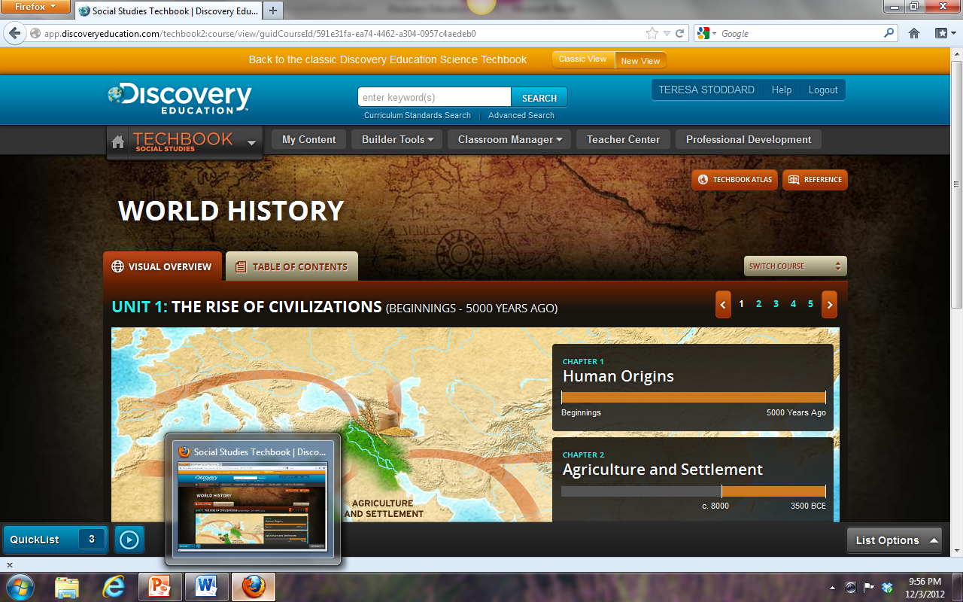
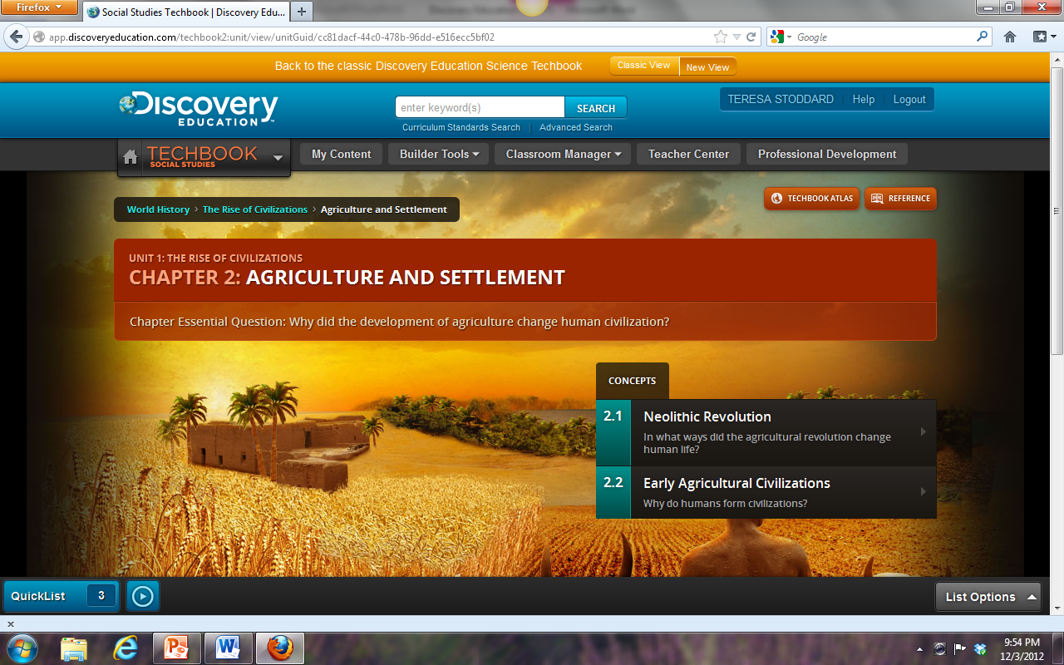
  - Hint—Follow the bread crumbs.
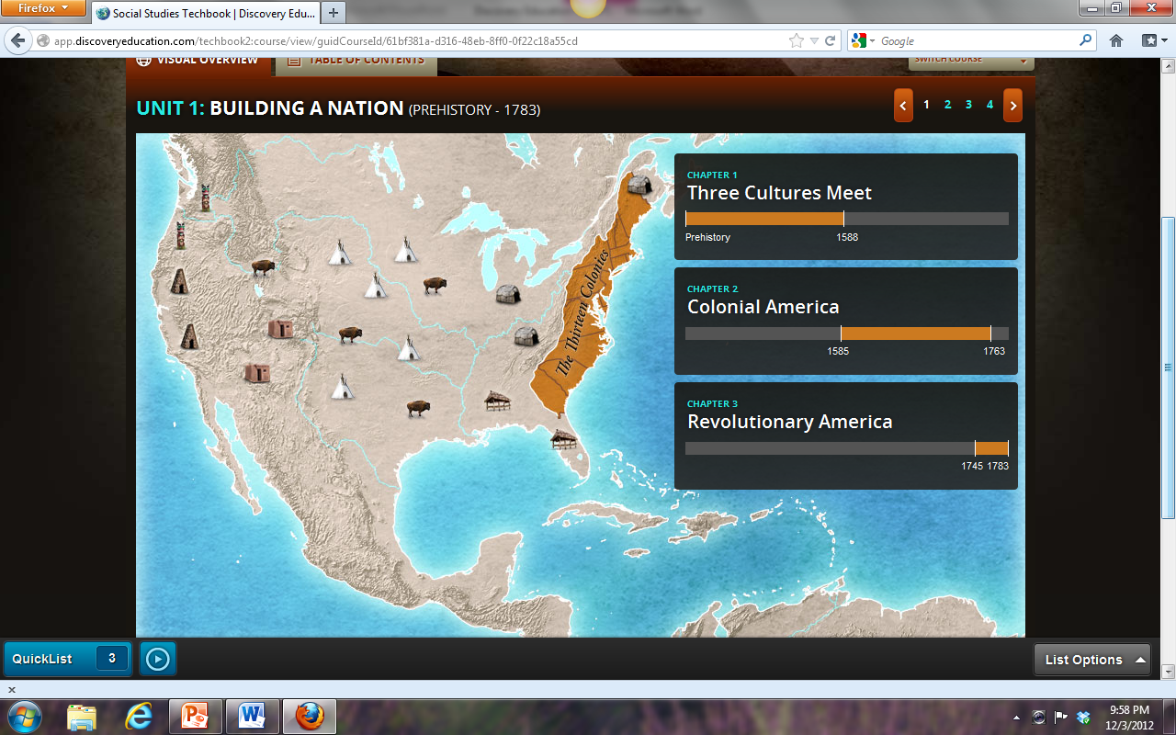

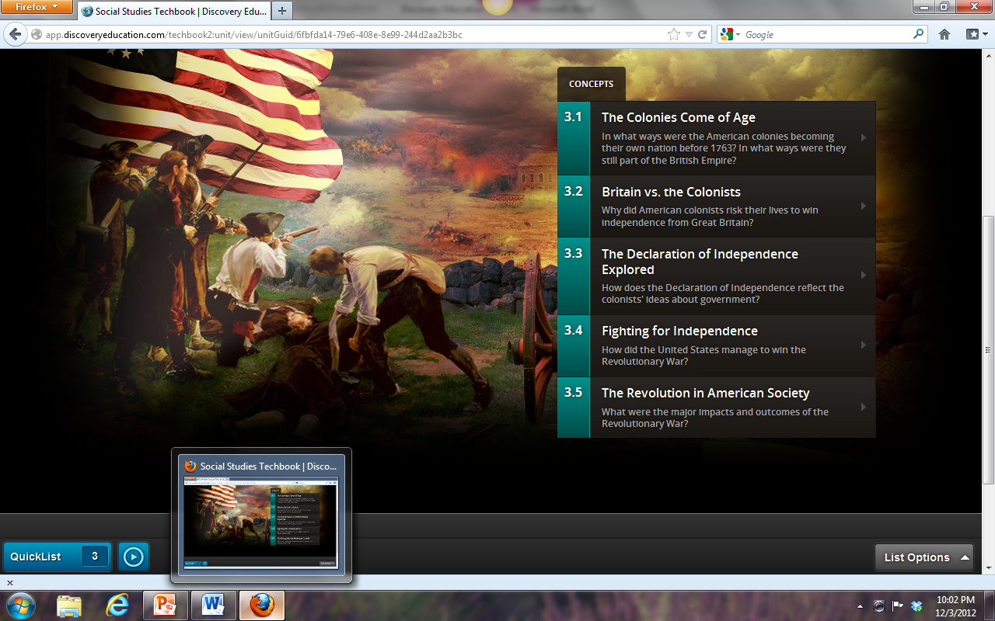

Did you find it?
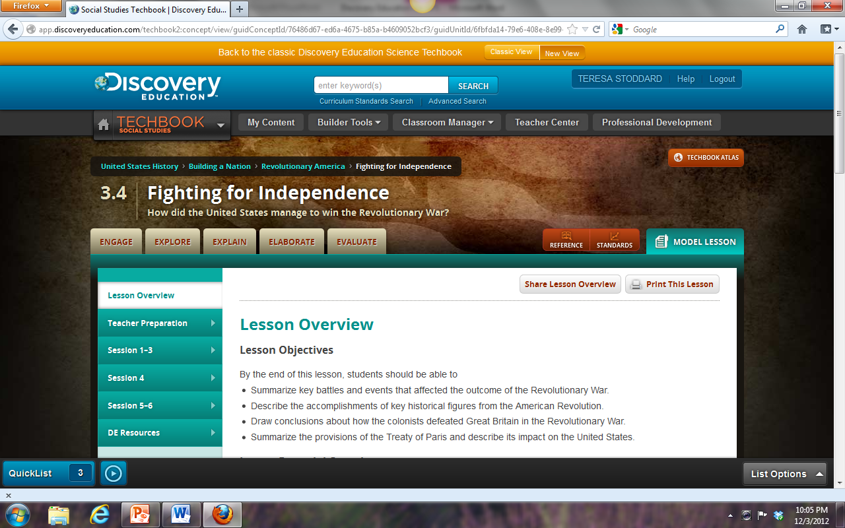

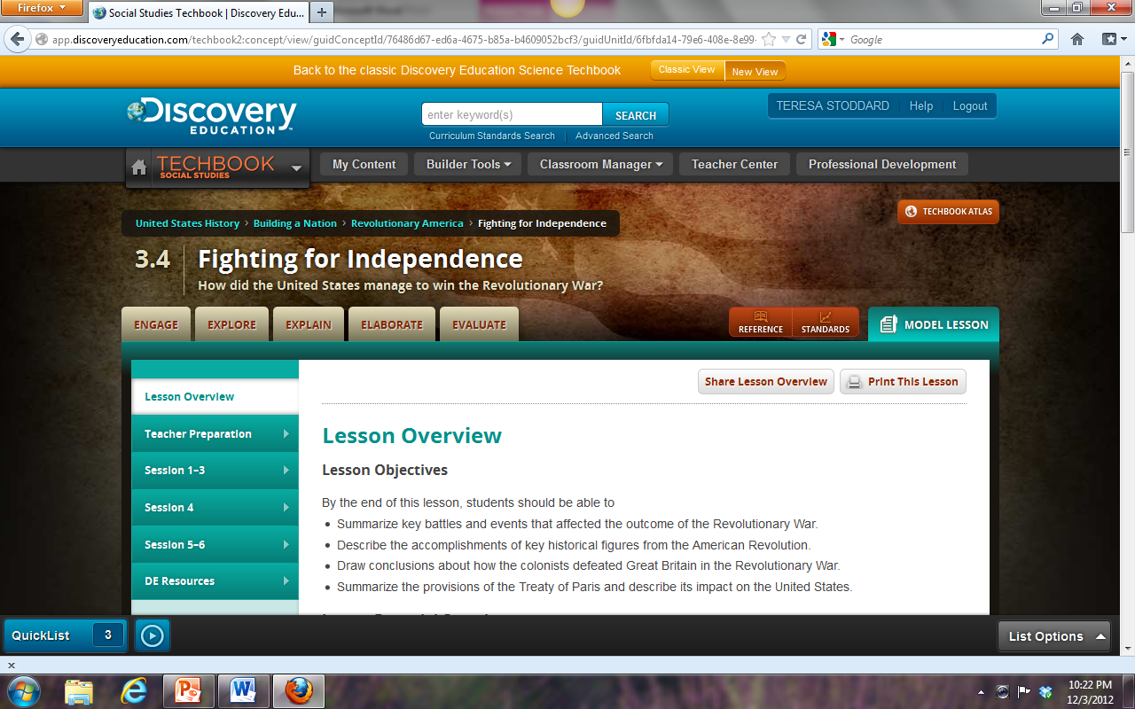
- Model Lesson 3.4 Fighting for Independence
Students do not see the menu for teacher.
  - Lesson Overview, Teacher Preparation, Sessions, DE Resources
    - These menu options are for lesson planning.
  - Engage—Activate prior knowledge and stimulate interest. Find out what the students want to know (KWL).
  - Explore—The main source of content. Provides a variety of sources for students to explore when completing the lesson on their own.
I print this section and make copies for the students. I select the resources to show on the Promethean Board.
  - Explain—Activities give students the opportunity to explain what they know. They may need to revisit the Explore tab to review the information.
  - Elaborate—Going beyond what students know. Application of their knowledge.
  - Evaluate—For students to see their progress of what they learned.
- Downloading Videos
  - Use Firefox as the web browser.
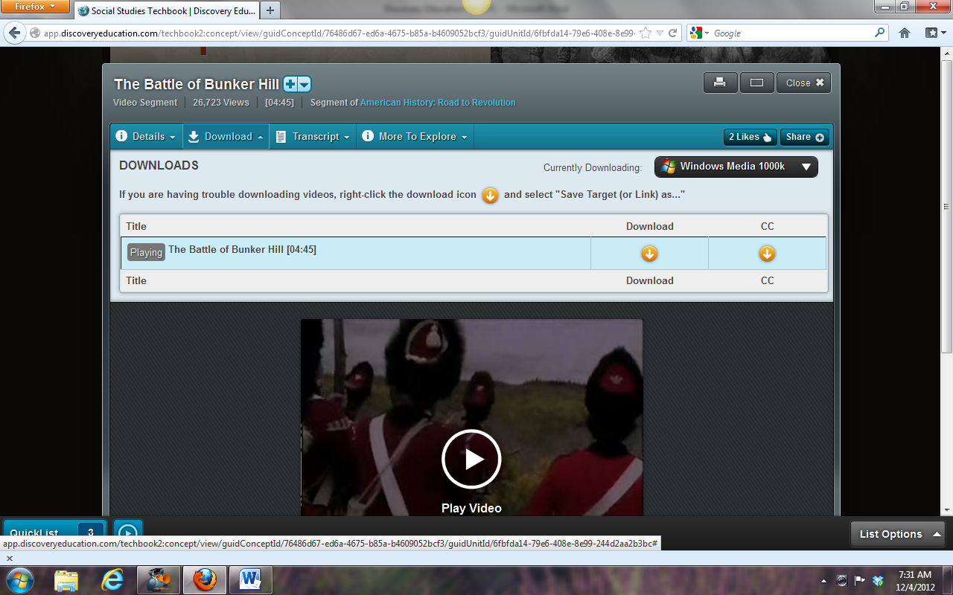
  - Click on View Video Segment.

  - Windows Media works well with PCs.
  - Click on Download. CC is for closed captioning.
  - Saving the file will let you use it for later.
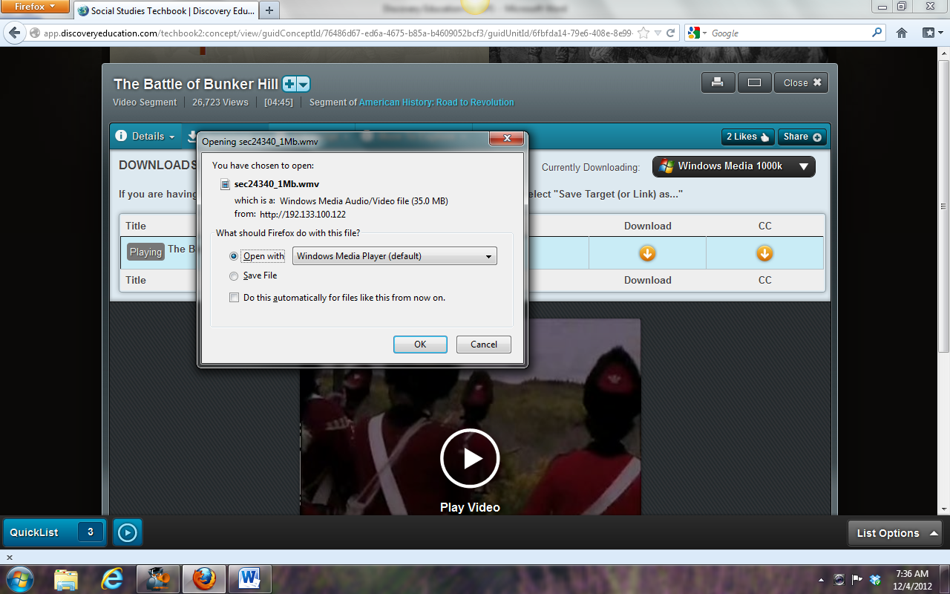

- Citations
  - The Details tab appears in the box when you download media.
    - Use the print view for easier copying.

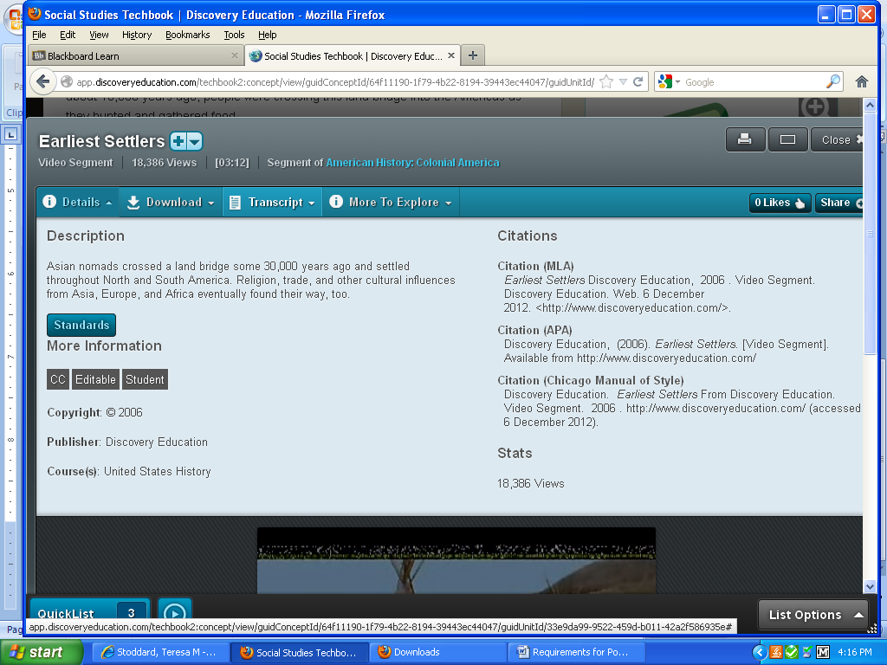

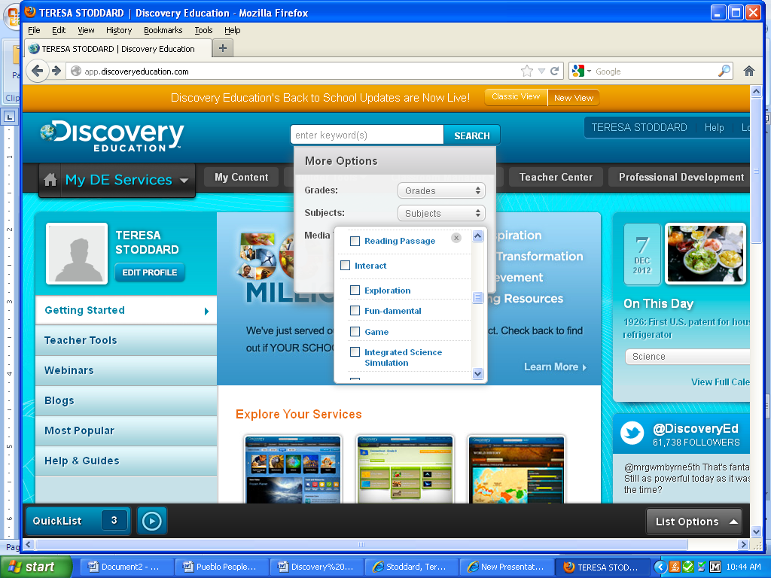
- Search
This feature allows you to search by grade level, subject, and media.
  - After you choose the criteria for each area, click on the
to close and go to the next search area.

Please feel free to email me if you have any questions.
Teresa Stoddard
Madison Middle School
stoddard_t@aps.edu

